**SCRUM Framework**

Scrum is an Agile project management framework designed to handle complex product development through collaboration, accountability, and iterative progress. It organizes work into small, manageable cycles called Sprints, typically lasting two to four weeks.

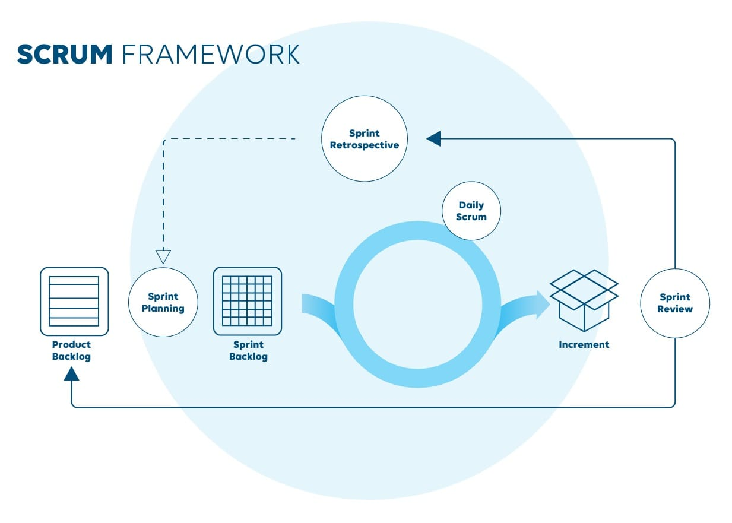

The Scrum Team consists of three main roles:

1.Product Owner: Responsible for setting clear goals and prioritizing features based on business value.

2.Scrum Master: Acts as a facilitator, helping the team stay true to Scrum practices and removing obstacles.

3.Development Team: A self-organizing, cross-functional group that delivers the actual product increment.

Scrum uses three main artifacts:

1.Product Backlog: A dynamic list of features, enhancements, and fixes needed for the product.

2.Sprint Backlog: A subset of Product Backlog items chosen for a Sprint, along with a plan for delivering them.

3.Increment: The functional product output produced at the end of each Sprint, which should be potentially shippable.

Key events in Scrum include:

* Sprint Planning: Setting the Sprint goal and selecting work.
* Daily Scrum: A 15-minute stand-up meeting to align the team’s efforts.
* Sprint Review: A meeting to demonstrate the completed work to stakeholders.
* Sprint Retrospective: A reflection session to improve future Sprints.
* Scrum emphasizes transparency, inspection, and adaptation, helping teams remain flexible, identify problems early, and continuously deliver value.
* Unlike traditional project management, Scrum encourages frequent reassessment of both the product and the process, fostering a culture of learning and innovation.